HW 4 Linear Panel Data

Yaxuan Jiao

4/15/2019

**Exercise 1 Data**

* Represent the panel dimension of wages for 5 randomly selected individuals

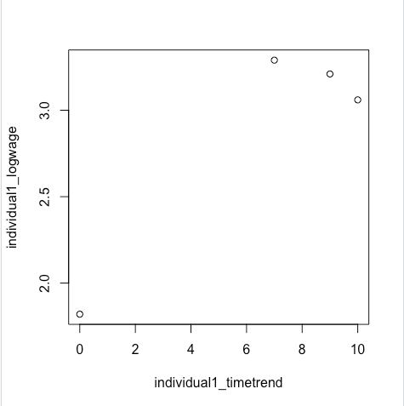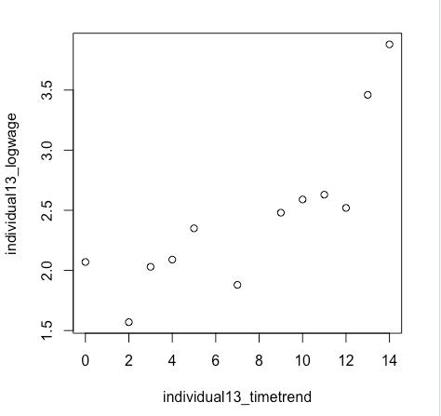

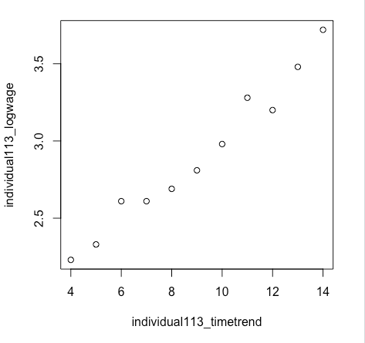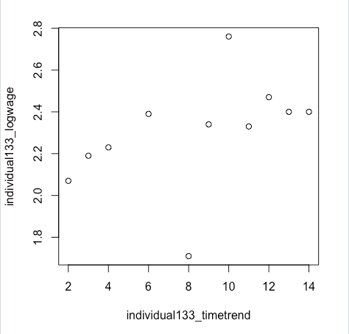

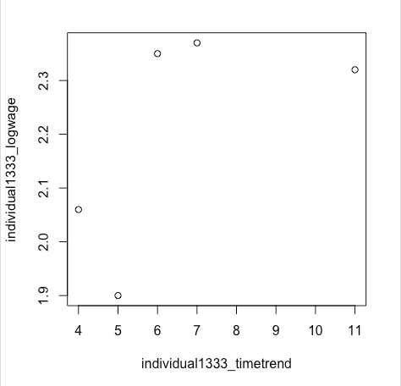unbalanced panel dataset

**Exercise 2 Random Effects**

* Estimate the **random effect model** using GLS

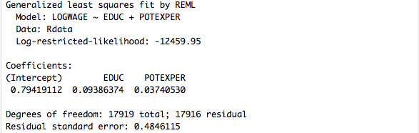

**check the estimate results by “plm” function**

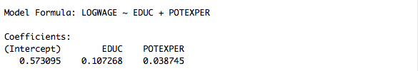

**Exercise 3 Fixed Effects Model**

* Estimate **between estimator**

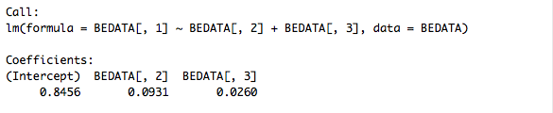

**check the estimate results by “plm” function**

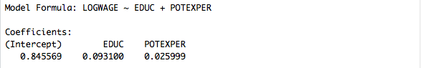

* Estimate **within estimator**

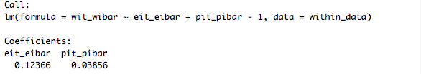

**check the estimate results by “plm” function**

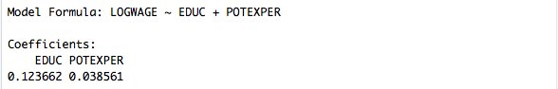

* Estimate **first time difference estimator**

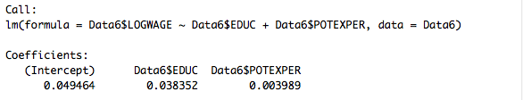

**check the estimate results by “plm” function**

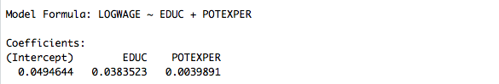

* Compare the estimates of $β_{1}$ and $β_{2}$ under the different models

Among estimates, between estimator provides an estimate for the fixed individual effect, which is 0.8456. Meanwhile, the estimate coefficient of potential experience is relatively consistent, but the estimate coefficient of education varies a lot, especially for the first time difference estimator. I think it's probably because the time-invariant property of the education variable.

**Exercise 4 Understanding Fixed Effects**

* Write and optimize the likelihood associated to the problem and estimate the individual fixed effect parameters



* Run a regression of estimated individual fixed effects on the invariant variables

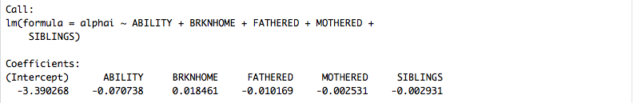

* The standard errors in the previous may not be correctly estimated. Explain why, and propose an alternative method to compute standard errors



The errors may be potentially (1) serially correlated and/or (2) heteroscedastic. For example, consider an OLS regression of $Y_{it}-Y_{i}$ on $X_{it}-X_{i}$, ignoring the correlation over time for given individual can lead to greatly underestimated standard errors and over-estimated t-statistics.

An alternative method to compute standard errors is called the Panel-Robust Sandwich Standard Errors, which is computed by the asymptotic variance matrix of the OLS estimator and correct for both serial correlation and heteroscedasticity.